Sidney x Razz breeding

Puppy pedigree:
file:///C:/Users/nancy/Documents/Sidney%203/Sidney%20x%20Razz%20puppy%20pedigree.pdf
Title definitions:
CH – Show Champion
FC – Field Champion
AFC – Amateur Field Champion
NFC – National Field Champion
NAFC – National Amateur Field Champion
DC – Dual Show and Field Champion (less than 300 Vizslas have this title)
MH – Master hunter
NAVHDA – North American Versatile Hunting Dog Association

*There is a lot of royalty behind this litter

Sidney’s Health Checks
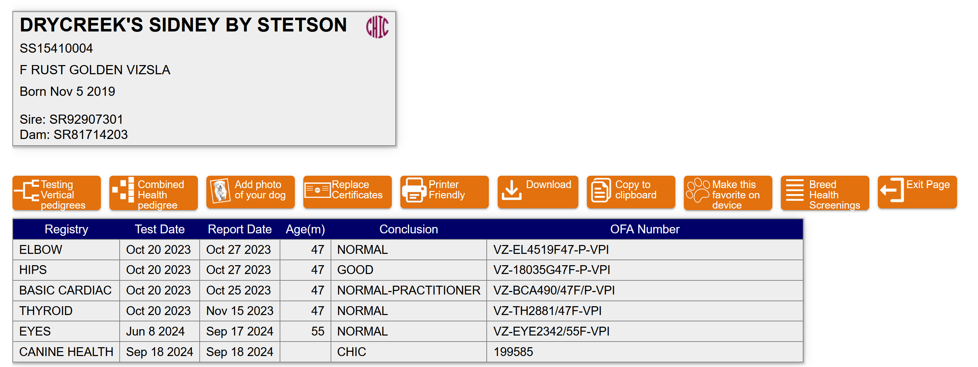

Sidney’s nice conformation
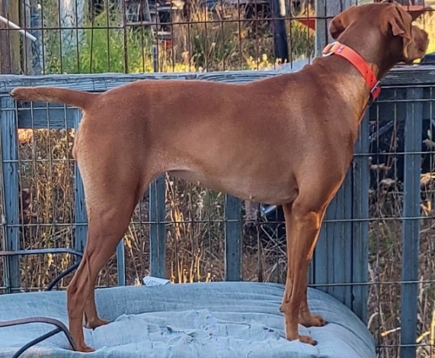

Sidney’s beautiful movement
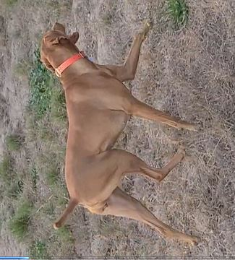

6 month old Sidney daughter, Lola, loves birds too
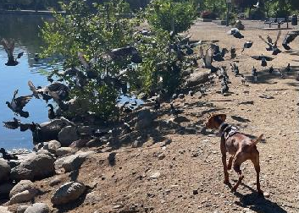

6 month old Sidney daughter, Daisy. She is the spitting image of Sid
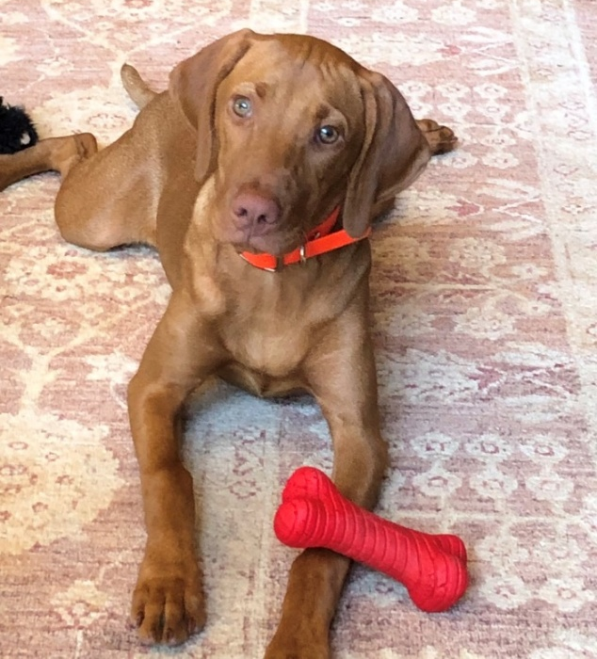

Sidney’s temperament is solid. Her happy tail is constantly wagging. She LOVES birds and loves to retrieve – often retrieving her hunting partner’s birds (we are working on that ). She is great with new people and is good with other dogs. Sidney is my hunting companion. She runs independent and big and has a great nose. She will retrieve in water. In the home, Sidney is quiet and loves to snuggle next to one of her humans. She is confident – gun fire, fireworks and thunder do not bother her. She is a very pretty female.

Razz’s health checks
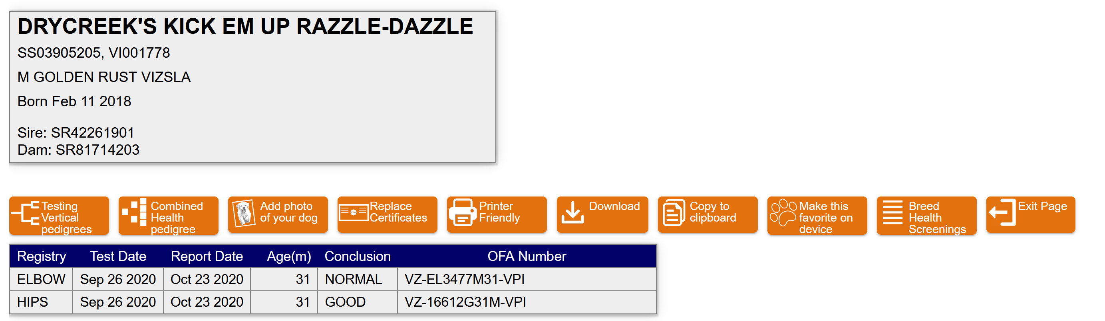

Razz retrieving pheasant
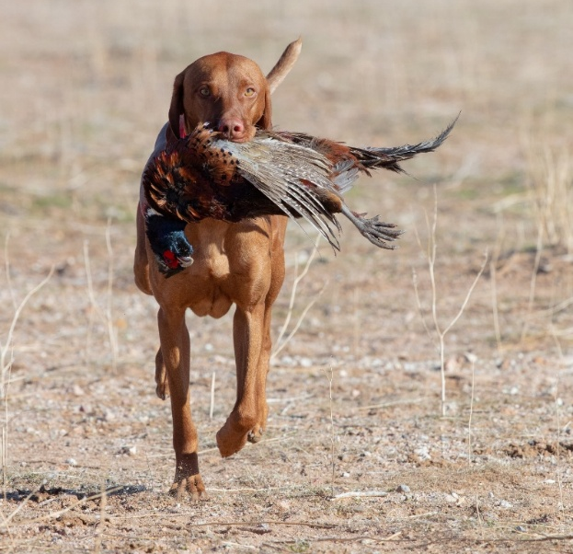

Razz on point
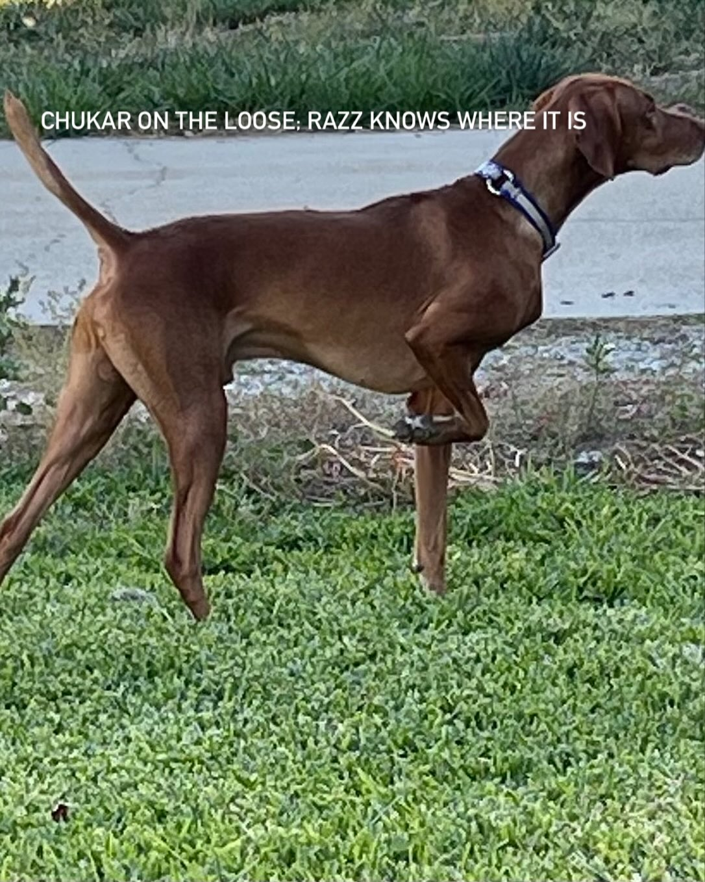

Razz having just retrieved his duck in water
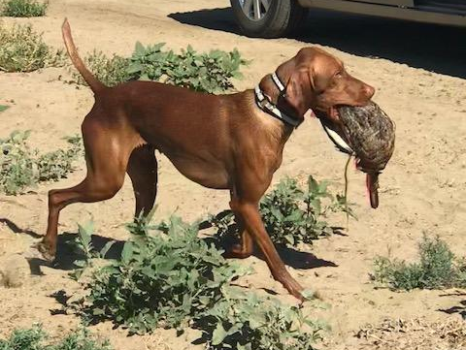

Razz daughter on point
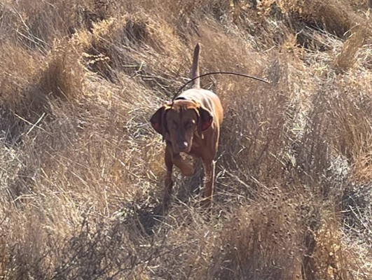

Razz is a happy dog. Nothing bothers him. Just a great all-around temperament. His success in NAVHDA and earned MH speaks to his hunting prowess. Razz has a lot of prey drive. He runs big, independent and smart. He retrieves upland birds on land and ducks in water without hesitation. And he is an awesomely fast swimmer. He is a very sweet boy who is friendly with new people, children and other dogs. He lives with a few other female Vizslas and loves his mom. He is confident – gun fire, fireworks and thunder do not bother him. Razz is a lovely boy.

